Practical – 6

Definition: Demonstrates the complete process of using Power BI to import, clean, transform, model, and visualize data to generate meaningful business insights.
Learning Outcome: Learned to prepare datasets, establish relationships, and create interactive dashboards in Power BI that communicate insights clearly.
Required Tools: Microsoft Power BI Desktop & Power Query Editor
Working: The practical begins by importing both the Orders and Order Details datasets into Power BI. The data is then cleaned and transformed to ensure consistency and accuracy. A relationship is established between the two datasets using the common field OrderID, allowing analysis at both customer and product levels. Once the model is ready, calculated fields are created for sales and discounted sales. Finally, different types of visualizations are built to uncover trends and insights in e-market performance.
Dataset Overview: The Orders table consists of attributes like OrderID, Customer Name, Order Date, and Country, which provide customer-level and transaction-level details. The Order Details table contains OrderID, Product Name, Quantity, Unit Price, and Discount, which represent item-level sales.
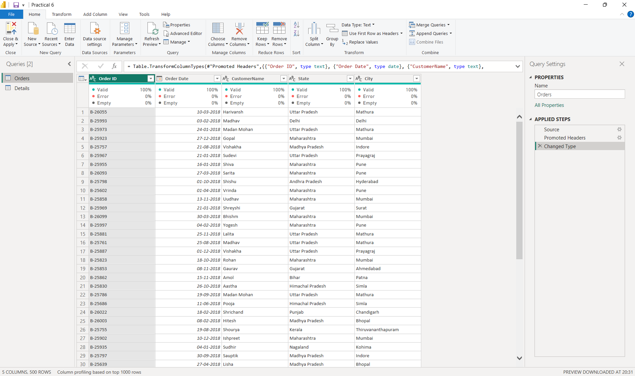

Step 1: Loading Data into Power BI: The datasets were loaded into Power BI using the “Get Data” option. Orders and Order Details were imported separately and placed into the Power Query Editor for cleaning and transformation. After applying the necessary steps, the data was loaded into the Power BI workspace for modelling and visualization.
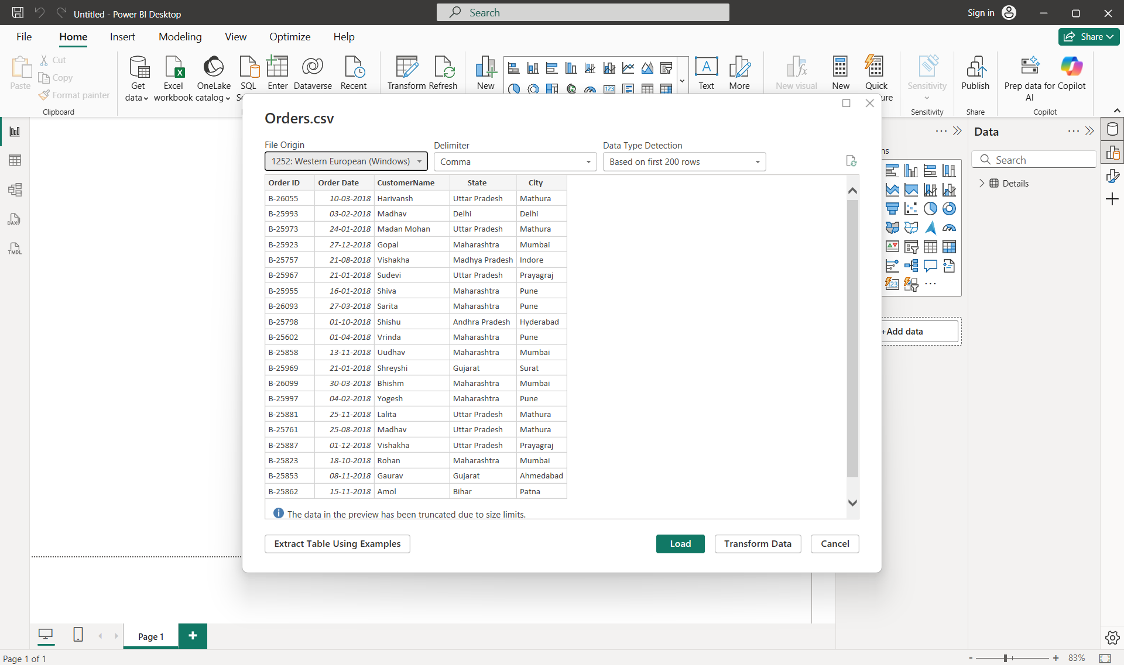

Step 2: Data Modelling: In the Model View of Power BI, a one-to-many relationship was created between the Orders table and the Order Details table using OrderID as the primary key. The Orders table, containing unique order entries, represents the “one” side, while the Order Details table, which may contain multiple products per order, represents the “many” side. This relationship enabled smooth aggregation of order-level and product-level information during analysis.
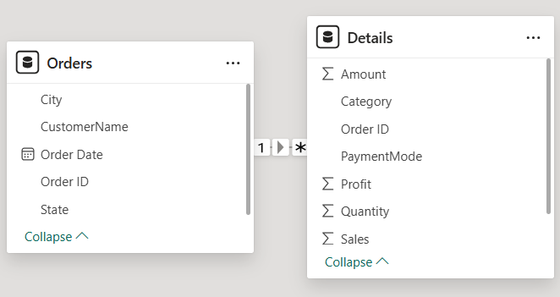

Step 3: Data Cleaning and Transformation: The data cleaning process involved removing duplicate rows, handling missing values in fields like Customer Name and Product, and dropping irrelevant columns. Standardization was applied to categorical values, such as country names and product names, ensuring uniformity. Dates were formatted consistently to enable time-series analysis.
Transformations included creating calculated columns such as Total Sales (Quantity × Unit Price) and Discounted Sales ((Quantity × Unit Price) – Discount). From the Order Date column, Year and Month were extracted to study monthly and yearly trends. These transformations enhanced the dataset, making it more analytical and suitable for visualization.
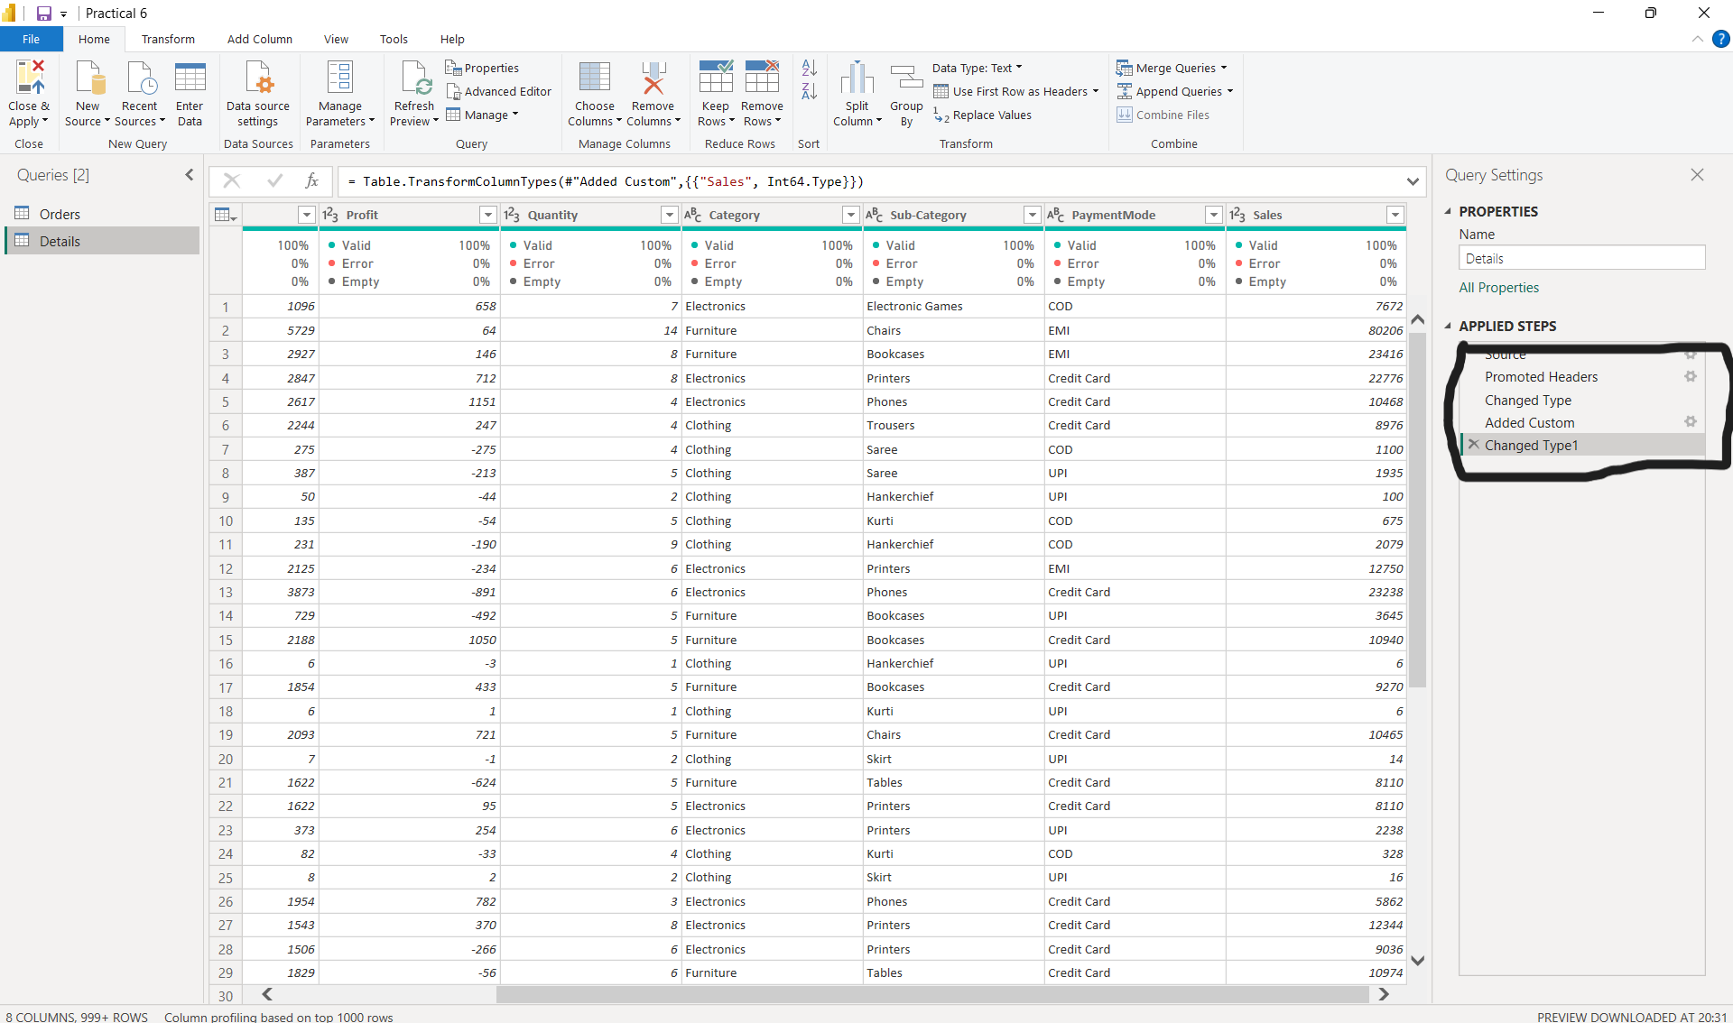

Step 4: Building Visualisations: To gain actionable insights from the India E-Market dataset, a series of visualizations were created in Power BI to analyse sales, profit, and customer behavior across different regions and categories. A line and clustered column chart was used to compare Total Sales and Profit across various Categories and Sub-Categories, highlighting the most profitable product segments. A Treemap showcased the top three orders by state, providing a clear view of the highest revenue-generating regions.
A stacked column chart analysed profit distribution across the top five and five lowest-performing cities, identifying areas of strong and weak profitability. Area charts were employed to track Sales and Profit trends over time, as well as Average Sales and Quantity by month, revealing temporal patterns and growth opportunities. Another Treemap highlighted the Top 10 Customers by Total Spending, emphasizing key contributors to revenue.
A map visualization displayed Orders and Quantity by state and city, giving a geographic perspective of sales density. Finally, a pie chart illustrated the distribution of orders by Payment Mode, providing insights into customer preferences for transaction methods.
Together, these visualizations formed an interactive and cohesive dashboard, enabling detailed exploration of sales performance, profitability, customer behaviour, and regional trends across India, supporting data-driven strategic decision-making for the e-market.
